**Evolution of Networking**

**Need of a Network:** An “network” additionally enables associated PCs to share documents and information and also equipment assets, i.e., scanners, plotters, projectors and storage devices, making it simpler to gather and administer data, and enabling clients to work together.

The system was simply not advanced in one day; rather took a long time to be an all the more incredible, productive and dependable system. Advancement of systems administration began path back in 1969’s by the improvement of first system called ARPANET, which prompted the improvement of web. At that point after constantly everyday upgradation occur in the system innovation. The system has gone through a few phases which are described below:

**ARPANET (Advanced Research Agency Network):**  
ARPANET was the network that became the basis for the Internet. It was the first network that came into existence in 1969, which was designed and named by the Advanced Research Projects Agency (ARPA) and US Department of Defence (DoD). It was where a bunch of PCs were associated at various colleges and US DoD for sharing of information and messages and playing long separation diversions and associating with individuals to share their perspectives.

**NSFNET (National Science Federation Network):**  
In mid 80’s another federal agency, NSFNET (National Science Federation Network) created a new network which was more capable than ARPANET and became the first backbone infrastructure for the commercial public Internet. Its main aim was to use network only for academic research and not for any kind of private business activity. Later, many privately owned businesses with their very own private systems joined with ARPANET and NSFNET to make more capable and wide network, the Internet.

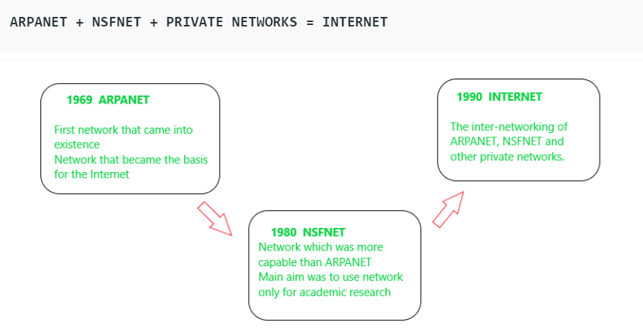

**Internet:**

In the Internet, which is a network of networks, came into existence. The internet has evolved from ARPANET. The internet is a globally connected network system that utilizes TCP/IP to transmit information. It allows computers of different types to exchange information and is known as internet. The Internet is the financially communications method on the planet, in which the following services are instantly available:

* Email
* Web-enabled audio/video conferencing services
* Online movies and gaming
* Data transfer/file-sharing, often through File Transfer Protocol (FTP)
* Instant messaging
* Internet forums
* Social networking
* Online shopping
* Financial services

**Interspace:**

Interspace is a software that allows multiple users in a client-server environment to communicate with each other to send and receive data of various types such as data files, video, audio and textual data. Interspace gives the most exceptional type form of communication available on the Internet today.

**Switching Techniques**

In large networks, there can be multiple paths from sender to receiver. The switching technique will decide the best route for data transmission.

Switching technique is used to connect the systems for making one-to-one communication.

|  |  |
| --- | --- |
| **Circuit Switching** | **Packet Switching** |
| In circuit switching there are 3 phases: i) Connection Establishment. ii) Data Transfer. iii) Connection Released. | In Packet switching directly data transfer takes place . |
| In circuit switching, each data unit know the entire path address which is provided by the source. | In Packet switching, each data unit just know the final destination address intermediate path is decided by the routers. |
| In Circuit switching, data is processed at source system only | In Packet switching, data is processed at all intermediate node including source system. |
| Delay between data units in circuit switching is uniform. | Delay between data units in packet switching is not uniform. |
| Resource reservation is the feature of circuit switching because path is fixed for data transmission. | There is no resource reservation because bandwidth is shared among users. |
| Circuit switching is more reliable. | Packet switching is less reliable. |
| Wastage of resources are more in Circuit Switching | Less wastage of resources as compared to Circuit Switching |
| It is not a store and forward technique. | It is a store and forward technique. |
| Transmission of the data is done by the source. | Transmission of the data is done not only by the source, but also by the intermediate routers. |
| Congestion can occur during connection establishment time, there might be a case will requesting for channel the channel is already occupied. | Congestion can occur during data transfer phase, large number of packets comes in no time. |
| Circuit switching is not convenient for handling bilateral traffic. | Packet switching is suitable for handling bilateral traffic. |
| In Circuit switching, charge depend on time and distance, not on traffic in the network. | In Packet switching, charge is based on the number of bytes and connection time. |
| Recording of packet is never possible in circuit switching. | While recording of packet is possible in packet switching. |